Certificate of Recognition
Presented to
Your Name
Your Region

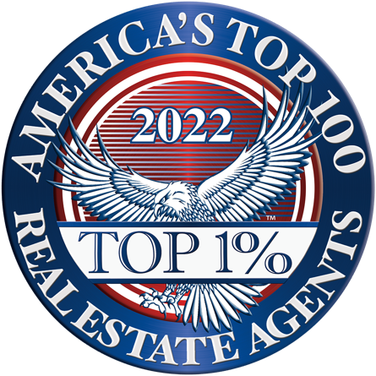

acknowledging your exceptional talents and achievements ranking you among the
Top 1% of Real Estate Agents and Brokers throughout the nation and earning
your selection to America’s Top 100 Real Estate Agents®.

Awarded on this | 28th | day of | October
Kevin Wieser
Kevin Wieser – Membership Director

AMERICA’S TOP 100 REAL ESTATE AGENTS®

